HARDWARE AND COMPONENTS BASICS

ASSIGNMENT DAY 4
TASK1. Open your own laptop or desktop (or use an online PC hardware simulator if you don't have access to a real system) and identify the GPU model installed. Write down the GPU's brand, model number, and whether it is integrated or dedicated.
Specification | Details
Brand | Intel
Model Number | Intel UHD Graphics 630
Type | Integrated GPU

EX:- The Intel UHD Graphics 630 is an integrated graphics processor built into certain Intel Core processors. It shares system memory (RAM) and is suitable for everyday tasks, video streaming, and light gaming.

TASK2. Take a clear photo or screenshot of the cooling system (fan, heatsink, or liquid cooling setup) inside your PC or from a PC hardware simulator. Label the main cooling components and briefly describe their function.
- CPU cooling components including fan, heatsink, thermal paste, processor, and motherboard.
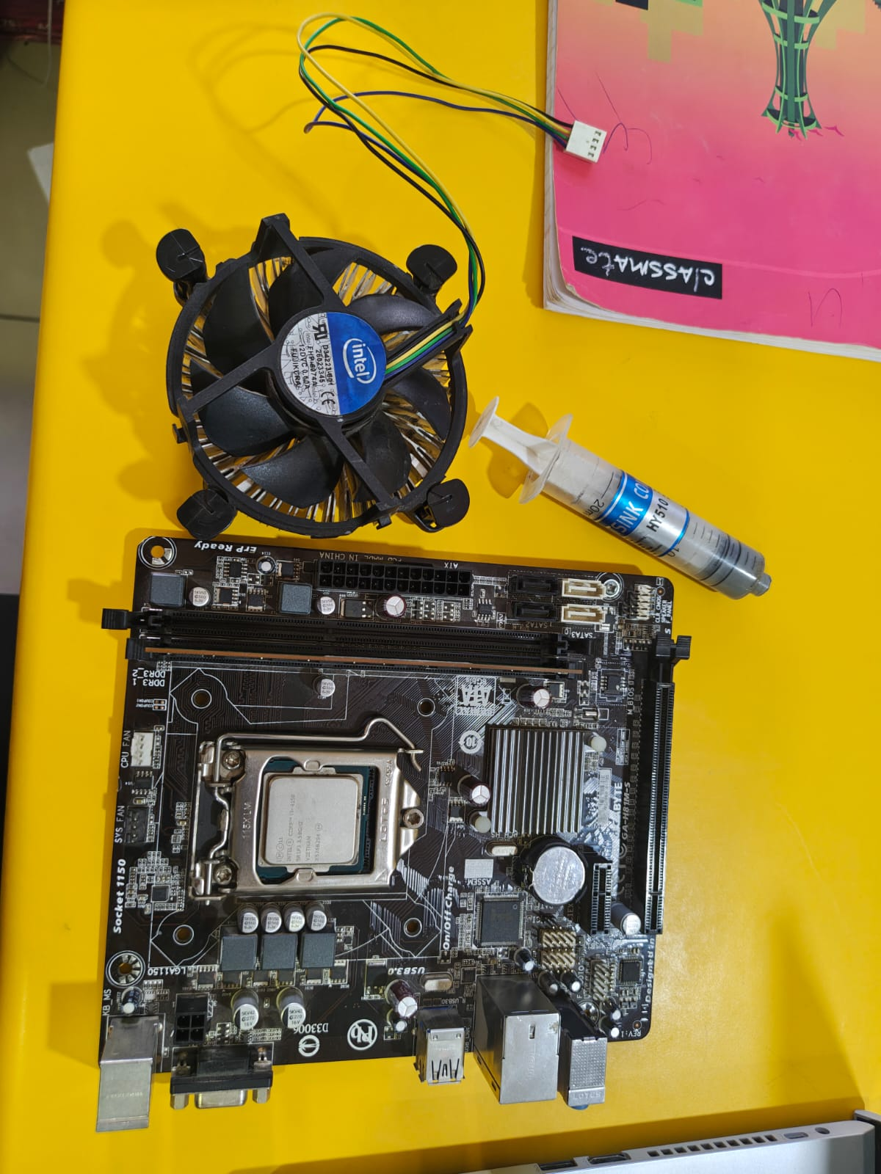
2.Colling system installation over the Processor.
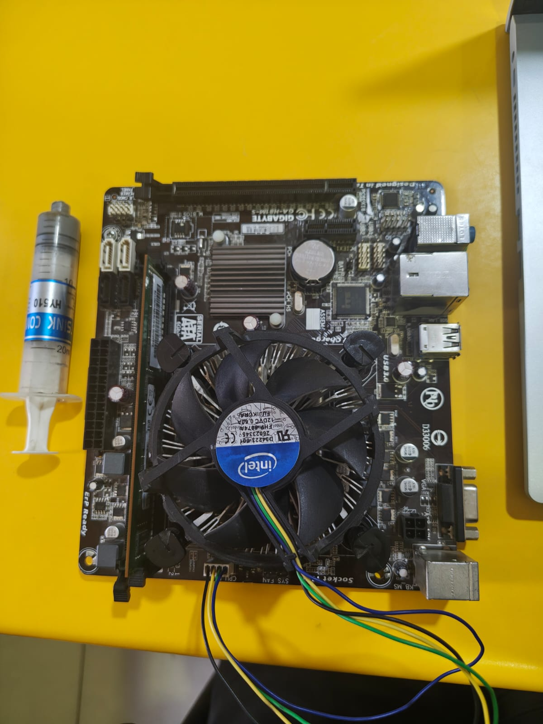
3.And there components-
Component | Function
CPU Cooling Fan | Pushes air through the heatsink to remove heat.
Heatsink | Absorbs and dissipates heat from the CPU.
Thermal Paste | Improves heat transfer between CPU and heatsink.
CPU | Generates heat while processing data.
Motherboard | Holds and connects all hardware components.

TASK3. Create a comparison table listing at least 3 differences between air cooling and liquid cooling systems for GPUs, including factors like cost, efficiency, and maintenance.
Feature | Air Cooling | Liquid Cooling
Cooling Method | Uses fans and heatsinks | Uses coolant, pump, and radiator
Cost | Less expensive | More expensive
Cooling Efficiency | Good | Excellent
Noise Level | Can be louder under heavy load | Usually quieter
Installation | Easy | More complex
Maintenance | Minimal | Requires periodic inspection
Risk | Very low | Small risk of leakage
Best For | General gaming PCs | High-end gaming and overclocking

TASK4. Imagine you are building a gaming PC for streaming IPL matches and playing graphics-heavy games. Choose between air cooling and liquid cooling for your GPU, and justify your choice in 3-4 sentences based on your research.
My Choice: Liquid Cooling
I would choose “liquid cooling” for a gaming PC used for streaming IPL matches and playing graphics-intensive games. Liquid cooling provides better temperature control during long gaming sessions and heavy GPU usage. It operates more quietly than many air coolers and helps maintain stable performance under load. Although it is more expensive, the improved cooling efficiency makes it a good choice for a high-performance gaming and streaming setup.

